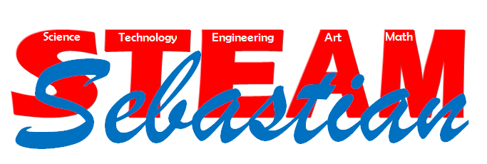

The Future of SMS: STEAM Education

What is STEAM?
STEAM education is a transformative approach to learning that guides students through an exciting world of curiosity, problem solving, and creativity. The core subjects of science and math are connected to language arts and social studies through interdisciplinary activities and units infused with the arts and technology. Students engage in inquiry activities and make real-world connections as they produce both digital and project based artifacts. These projects often incorporate the engineering design process and multiple technological tools. Students take on leadership roles in the STEAM environment and develop a deeper understanding of the conceptual connections within their subjects.

How will a STEAM program benefit SMS students in the future?
As we connect with our business partners and community members, we have discovered an urgent need for students talented in STEAM to fill jobs vital to our nation’s future. Employers tell us that nearly 80% of future careers will require some STEAM related skills, and it’s projected that by 2018, we will need 8.65 million workers in STEAM-related jobs. In a recent national survey, only 16% of high school students indicated a strong interest in a STEAM career and also demonstrated the required skills. Proficient STEAM students are:
- Technologically, scientifically, and mathematically literate
- Logical thinkers
- Able to investigate global issues
- Able to develop solutions for real-world challenges
Since middle school is when students begin to refine their career paths and interests, we believe our STEAM program will help increase awareness, interest, and knowledge related to this growing need. As SMS students engage in inquiry to answer complex questions and collaborate on creative solutions to real-world problems, they will experience a rigorous, meaningful, and fun STEAM education at Sebastian Middle School.
STEAM = Science & Technology interpreted through
Engineering & the Arts, all based in Mathematical elements.

