Hello, my name is Heather Hagy and I teach 2D Art at Sebastian Middle School. I am offering an Art & Design Club on Tuesdays after school. We will explore textile design, screen printing, mural work and t shirt design. My hope is to provide the other clubs at school with t shirts designed and printed by SMS students. I would also like to offer our services to local families if they would like custom work for their own events and businesses.

S.M.ART WORKS

ART & DESIGN CLUB @ Sebastian Middle School
Commitment: This is purely extra curricular, but students will be expected to behave, follow school rules, and participate. I will let students, (and you) know in advance when students will need to bring in supplies to participate. (This will only happen when students are making things for themselves. ) I will also communicate our calendar schedule to keep everyone informed.
Transportation: Your child can sign up in advance to take a SJCSD bus home, if you would like. The program will end at 3:20. At 3:30. students will pick up a bus that will take them to St. Augustine High School. From there, your child will be directed to the bus that will take them home. It is imperative to know in advance, so your student gets the bus # he or she will take home form SAHS. If you choose to pick up your child, it is important that they are picked up by 3:30.

Please provide the name of the student who wishes to participate, and your contact information.

Student Name:______________________________________________

Parent/Guardian Name:______________________________________

Phone #___________________________________________________

Email Address:______________________________________________

S.M.ART Works will meet on Tuesdays, beginning October 10.
Please contact me if you would like to volunteer, or if you have questions: heather.Hagy@stjohns.k12.fl.us
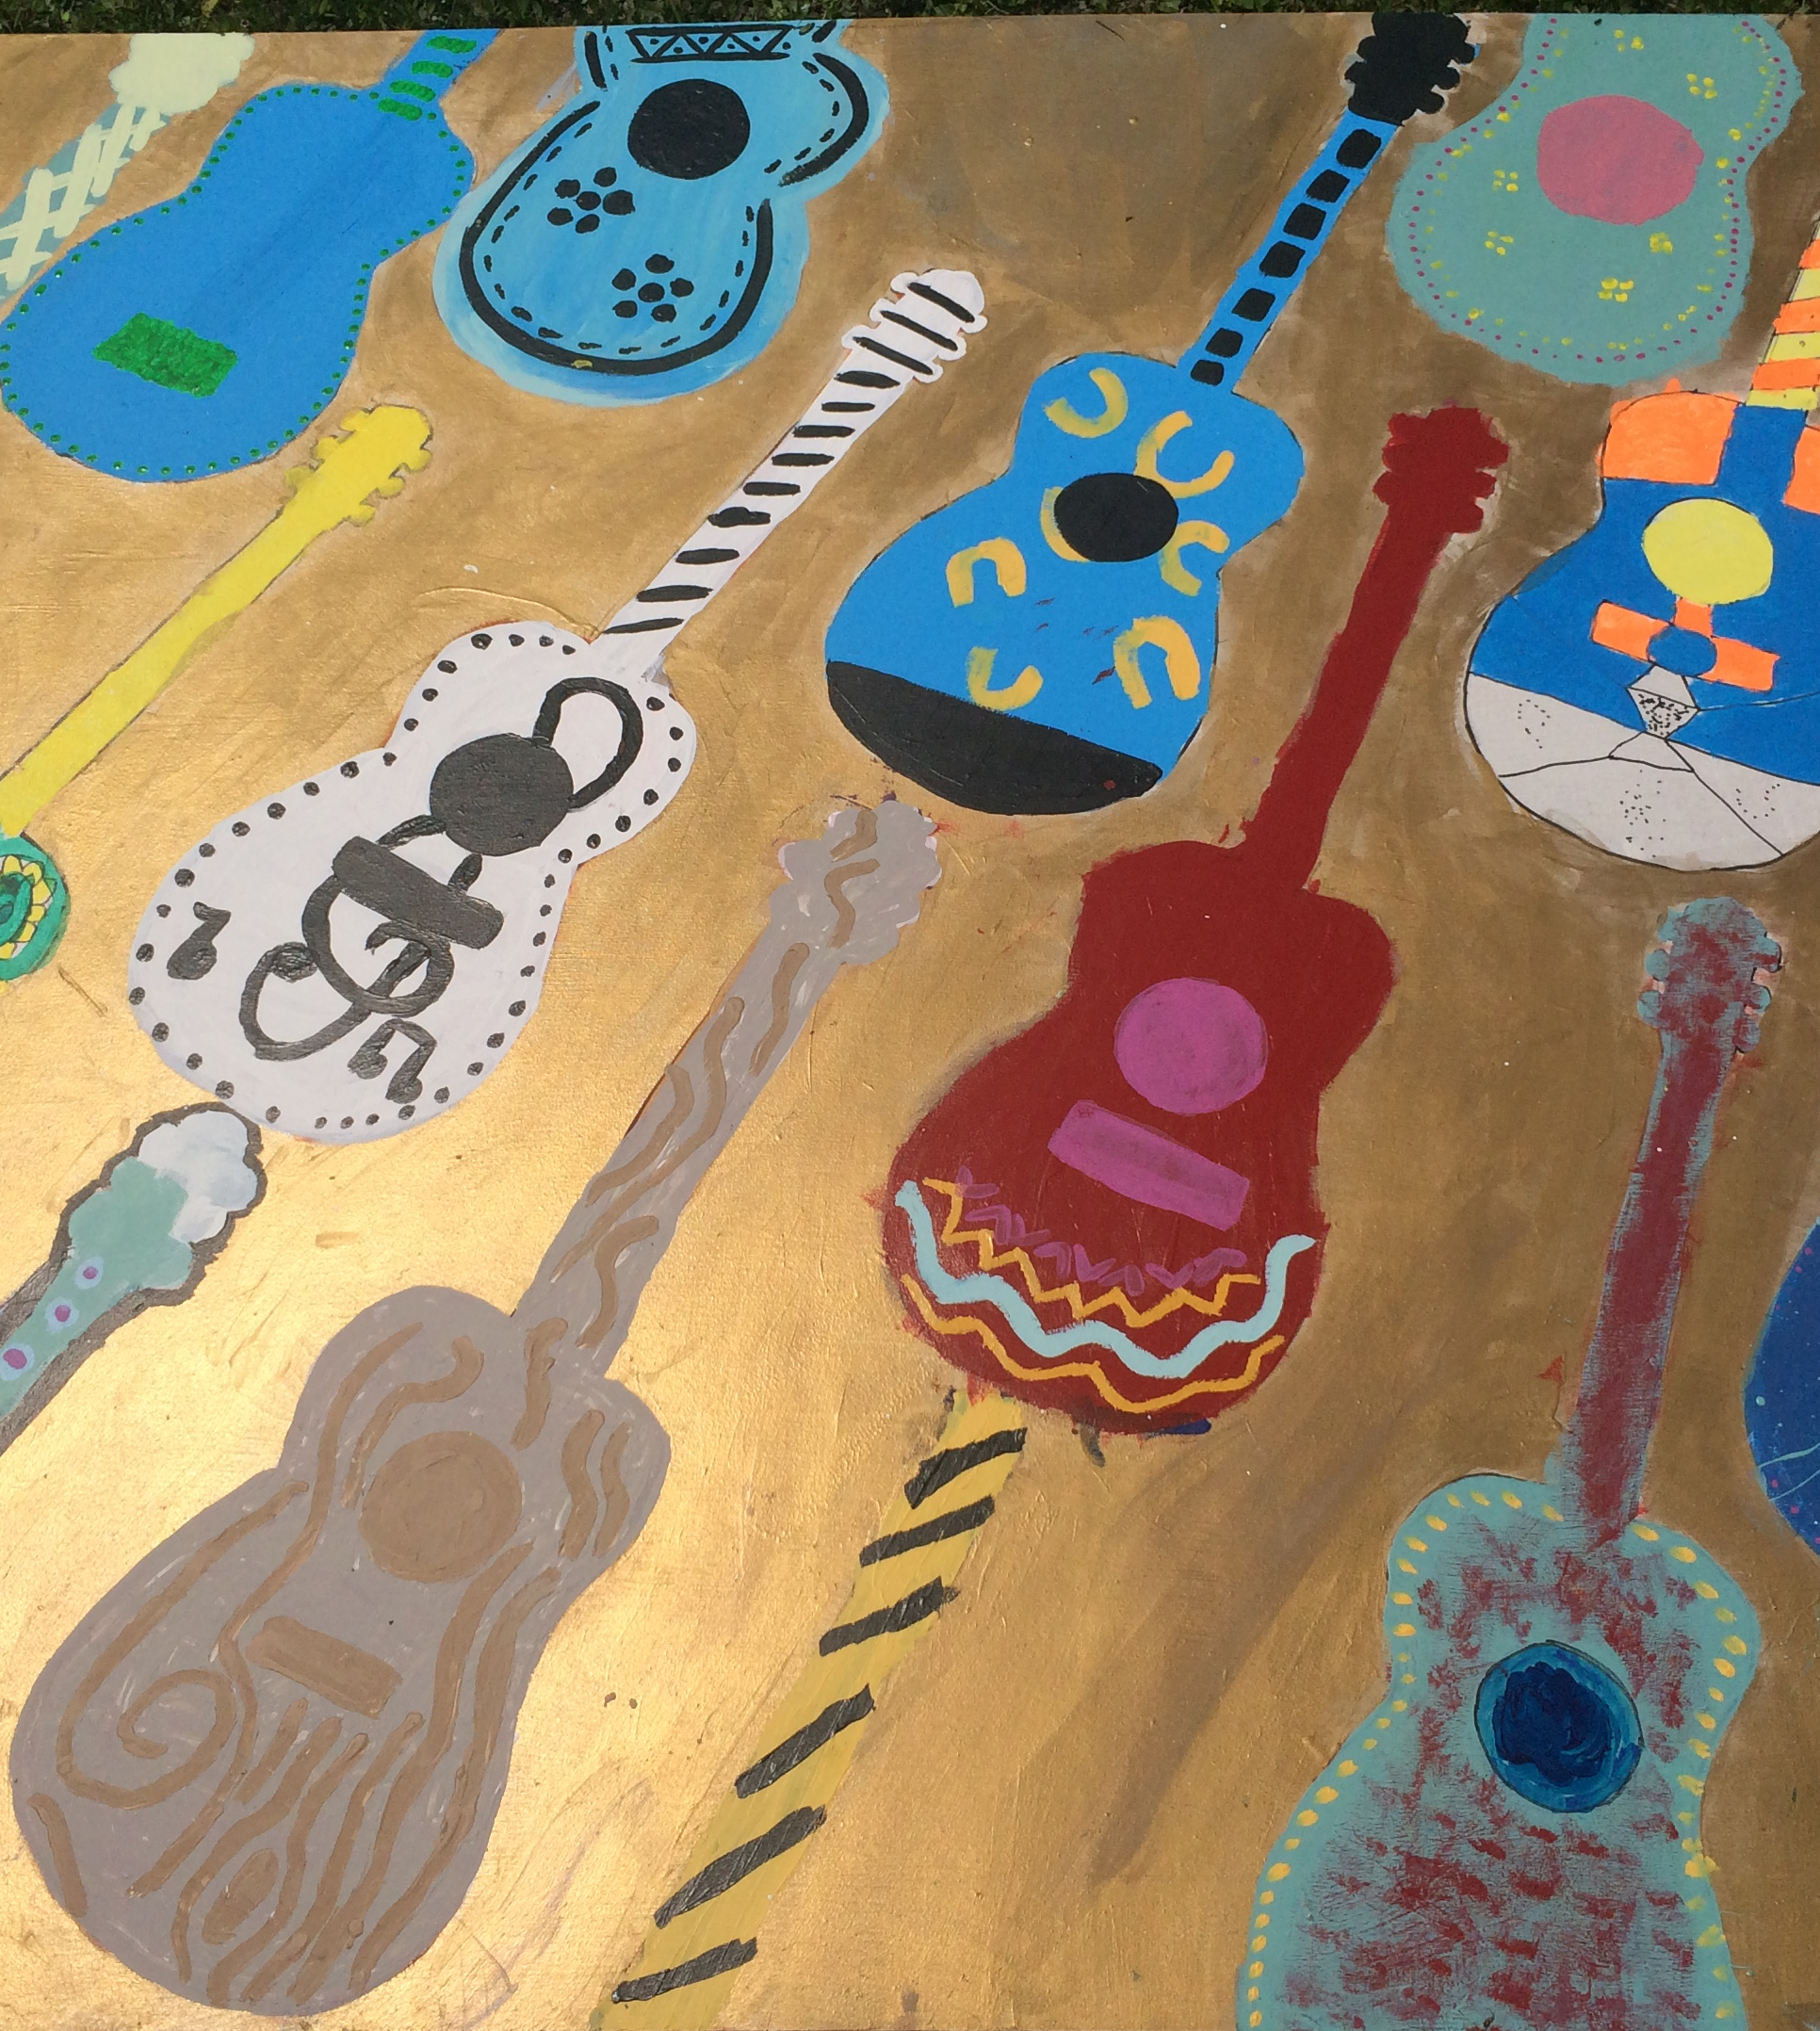
If your child needs extra time to work on Art projects, or Writing Reflections or Art Critiques, please let me know so I can provide support.
Guitar Mural painted by students last year for the Music Room

